LAB REPORT实验报告
Lab Title | String |  |  |  | Lab No. | 5
Stud. Name | Jiang Yunxiang | Major | CST |  | Class
Student ID | 2022102330 |  | Date | 3/24
Lab description/objectives:
Write a program that asks the user to input a string, the program will count and output the maximum number of consecutive repeating characters in the string.
Source code:
（Paste the source code here）
#include<stdio.h>
#include<string.h>
#define N 20
int main()
{
int maxnum=0, maximum = 0, num = 1;
char str[N];
gets(str);
for (int i = 0; i < strlen(str); i++)
{
if (str[i] == str[i + 1])
{
num += 1;
}
else num = 1;
if (num > maxnum)
{
maximum = str[i];
maxnum = num;
}
}
printf("The maximum number is %d, the character is %c", maxnum, maximum);
return 0;
}
Program outputs:
（Paste the screenshot of program output here）
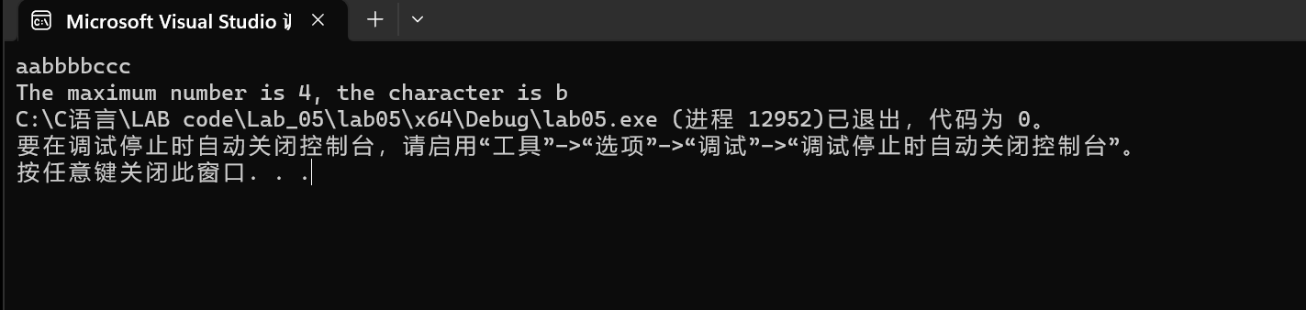
Discussion:
1．Most difficult parts
（What were the most difficult parts of your program to implement?）
To simplify the source code
2．Bugs and/or Errors
(List all the program bugs/errors you encountered and how you corrected them.)
Nope

